Morning Worship
THE LORD’S DAY
Sunday, January 18, 2026
8:30 and 11:00 a.m.
The Second Sunday after the Epiphany
“For you were once darkness, but now you are light in the Lord. Live as children of light (for the fruit of the light consists in all goodness, righteousness and truth) and find out what pleases the Lord.” Ephesians 5:8-10

Welcome Rev. Robert Castile

Prelude “Amazing Grace” Dwain Pesterfield

Prayer Wesley Rouse

*Hymns of Praise
“Joyful, Joyful, We Adore Thee”
Joyful, joyful, we adore Thee,
God of glory, Lord of love;
Hearts unfold like flowers before Thee,
Opening to the sun above.
Melt the clouds of sin and sadness,
Drive the dark of doubt away;
Giver of immortal gladness,
Fill us with the light of day.

All Thy works with joy surround Thee,
Earth and heaven reflect Thy rays,
Stars and angels sing around Thee,
Center of unbroken praise.
Field and forest, vale and mountain,
Flowery meadow, flashing sea,
Chanting bird and flowing fountain,
Call us to rejoice in Thee.

Thou art giving and forgiving,
Ever blessing, ever blest,
Well spring of the joy of living,
Ocean depth of happy rest!
Thou our Father, Christ our Brother
All who live in love are Thine;
Teach us how to love each other,
Lift us to the joy divine.

Mortals, join the mighty chorus
Which the morning stars began;
Love divine is reigning o’er us,
Binding all within its span.
Ever singing, march we onward,
Victors in the midst of strife,
Joyful music leads us sunward
In the triumph song of life.

“Glorious Day”
I was buried beneath my shame.
Who could carry that kind of weight?
It was my tomb 'til I met You.
I was breathing but not alive.
All my failures I tried to hide.
It was my tomb 'til I met You.

You called my name and I ran out of that grave!
Out of the darkness into Your glorious day!
You called my name and I ran out of that grave!
Out of the darkness into Your glorious day!

Now Your mercy has saved my soul.
Now Your freedom is all that I know.
The old made new, Jesus when I met You,
I needed rescue. My sin was heavy,
but chains break at the weight of Your glory.
I needed shelter. I was an orphan.
Now You call me a citizen of Heaven.
When I was broken, You were my healing;
now Your love is the air that I'm breathing
I have a future. My eyes are open.

Offertory Prayer Rev. Castile

Anthem Worship Choir & Orchestra

“This is Our God”
Remember those walls that we called sin and shame?
They were like prisons that we couldn't escape.
But He came, and He died, and He rose
Those walls are rubble now.

Remember those giants we called death and grave?
They were like mountains that stood in our way.
But He came, and He died, and He rose.
Those giants are dead now.

This is our God,
This is who He is, He loves us.
This is our God,
This is what He does, He saves us.
He bore the cross, beat the grave.
Let Heaven and Earth proclaim,
“This is our God, King Jesus.”

Remember that fear that took our breath away?
Faith so weak that we could barely pray?
But He heard every word, every whisper.

Now those altars in the wilderness
Tell the story of His faithfulness.
Never once did He fail, and He never will.

Who pulled me out of that pit? He did, He did.
Who paid for all of our sin? Nobody but Jesus.
Who pulled me out of that pit? He did, He did.
Who paid for all of our sin? Nobody but Jesus.

Who rescued me from that grave? Yahweh! Yahweh!
Who gets the glory and praise? Nobody but Jesus.
Who rescued me from that grave? Yahweh! Yahweh!
Who gets the glory and praise? Nobody but Him!
Children’s Sermon Rev. Gilbert Harris
Please be aware that if your child comes forward during this time, they will be visible on the livestream of the service.

*Passing the Peace Rev. Harris
Pre-K worship begins at 8:15a.m. and those children may be taken by a parent to their class anytime. K – 5th graders go to Kid’s Church during the “Passing of the Peace.” If you have not signed them up for Kid’s Church, please escort your child to the Great Hall.

*Hymn and Psalm of Faith
“The Lord is My Salvation”
The grace of God has reached for me,
And pulled me from the raging sea.
And I am safe on this solid ground.
The Lord is my salvation.

I will not fear when darkness falls.
His strength will help me scale these walls.
I'll see the dawn of the rising sun.
The Lord is my salvation.

Who is like the Lord our God,
Strong to save faithful in love.
My debt is paid and the victory won.
The Lord is my salvation.

My hope is hidden in the Lord.
He flow'rs each promise of His Word
When winter fades I know spring will come.
The Lord is my salvation.

Psalm 27:1-5, 13-14
The Lord is my light and my salvation—
whom shall I fear?
The Lord is the stronghold of my life—
of whom shall I be afraid?
When the wicked advance against me
to devour me,
it is my enemies and my foes
who will stumble and fall.
Though an army besiege me,
my heart will not fear;
though war break out against me,
even then I will be confident.
One thing I ask from the Lord,
this only do I seek:
that I may dwell in the house of the Lord
all the days of my life,
to gaze on the beauty of the Lord
and to seek him in his temple.
For in the day of trouble
he will keep me safe in his dwelling;
he will hide me in the shelter of his sacred tent
and set me high upon a rock.

I remain confident of this:
I will see the goodness of the Lord
in the land of the living.
Wait for the Lord;
be strong and take heart
and wait for the Lord.

Glory be to God the Father,
Glory be to God the Son.
Glory be to God the Spirit.
The Lord is our salvation.

Who is like the Lord our God,
Strong to save faithful in love.
My debt is paid and the victory won.
The Lord is my salvation.

Prayer Requests
You are invited to come forward and pray at the altar during the Family Prayer
time. If you would like to be anointed with oil and prayed for during this time, please meet Pastor Castile at the altar.

Family Prayer Rev. Harris

THE LORD’S PRAYER
Our Father, Who art in heaven, hallowed be Thy name. Thy kingdom come, Thy will be done on earth as it is in heaven. Give us this day our daily bread; and forgive us our trespasses as we forgive those who trespass against us. And lead us not into temptation, but deliver us from evil, for Thine is the kingdom, and the power and the glory forever. Amen.

*Scripture Reading John 8:12-30

Message “The Light of the World” Rev. Harris

*Hymn of Invitation
“Be Still for the Presence”
Be still, for the presence of the Lord,
the Holy One is here.
Come, bow before Him now,
with reverence and fear.
In Him no sin is found,
we stand on holy ground.
Be still, for the presence of the Lord,
the Holy One is here.

Be still, for the glory of the Lord
is shining all around.
He burns with holy fire,
with splendor He is crowned.
How awesome is the sight,
our radiant King of Light!
Be still, for the glory of the Lord
is shining all around.

Be still, for power of the Lord
is moving in this place.
He comes to cleanse and heal,
to minister His grace.
No work too hard for Him,
in faith receive from Him,
Be still, for the power of the Lord
is moving in this place.

*Benediction Rev. Harris

Christian sympathy is extended to Lucy Stoutt and family on the death of her husband, Ralph Stoutt.

Congratulations to Richard and Sarah Knapek on the birth of their son, Charles Knapek.
Prayer Requests
CHURCH STAFF:
Rev. Gilbert Harris, Senior Pastor
Rev. Robert Castile, Associate Pastor
Melissa Tyler, Executive Director
Wesley Rouse, Minister of Music
Robby Clemens, Administrative Assistant, Music Ministry
Marguerite Wardlaw, Organist, Music Ministry
Sandra Rouse, Pianist, Music Ministry
Mindy Richardson, Children’s Choir Coordinator, Music Ministry
Joshua Bauer, Audio/Visual Coordinator
Mallory Davis, Connectional Ministry Director
Sherrie Miller, Administrative Assistant, (Pastor)
Donna Henry, Children’s Ministry Director
Sophie Goss, Children’s Ministry Coordinator
Roger Murphy, College Ministry Coordinator
Donna Foster, Social Media Specialist/Receptionist
Jennifer Cowan, Bookkeeper
Christy Wheeler, Director, Preschool Ministry
Tom Palmer, Facilities Manager
Kenny Francis, Facilities Maintenance

Missionaries: Costa Rica – Paul and Amy Priest; Guatemala/Orphanage, Hogar del Nino; Surge - Bruce & Kathy Alwood; Latvia – Kristine Rozefelde; Paraguay – New Horizons Schools; Zimbabwe – Eben and Nancy Chinzvende; Haiti – Gabe Lindor (Simple Church); Haiti – Daniel and Natalie Abercrombie (Access Health Alliance)
US Based: Pennsylvania - Shane Claiborne; Tennessee: Raising a Voice, John 3:16, Isaiah House, Smoky Mountain Fellowship of Christian Athletes

Ongoing Health Requests: Kenny Allmon, Vicki Borden, Marge Fugate, Judy Granlund, Kermit Marcus, Wanda Marion, Raina Karras Myers, Virginia Porter, Michael (Mike) Smith, Rick Toombs, John Wilson.

Current Health Requests: Allen and Jo Beliles, Levi Briskie, Katie Langham, Linda Kidd, Sierra McConnaugley, Bill Merry, Billy Minser, Jessica Moore, Curtis Trent.

New Here?   | Prayers   | E-Giving   | Newsletter  
Military: Air Force – Charlene Carpenter, Will Gratz, Jeff Heath*, Chad Humphrey, Josh Humphrey, Jef Hyatt, Blaine Nicholson, Jacob Robbins, Danny Smith, Rob Toth, Robb Wilson*, Brian Wright, Jared Cassady. Army – Neal Buckingham, Christopher Cogburn, Luke Cox*, Tony Ellis, Casey Gillis (training), Brad Hutsell, Jason McGeorge, Obed McPherson*, Stewart Milne, Eli Tate, Wes Tate. Marines – Mikeala Buckingham, Tyler Buckingham, Elijah Dean*, Derek Reimann, Daniel Romans*. Navy – Jason Cassisi, Kurt Heidemann, Chandler Lekes*, Conner Lewis*, Austin Lyttle, Jonathan O'Bannon, Mark Robinson*, Alex Simmons, Jonah Watson*, Jesse Williamson*. Air National Guard –Tyler Isaacs*, Scott Pritchard, Zach Tate.
(*= Deployed)



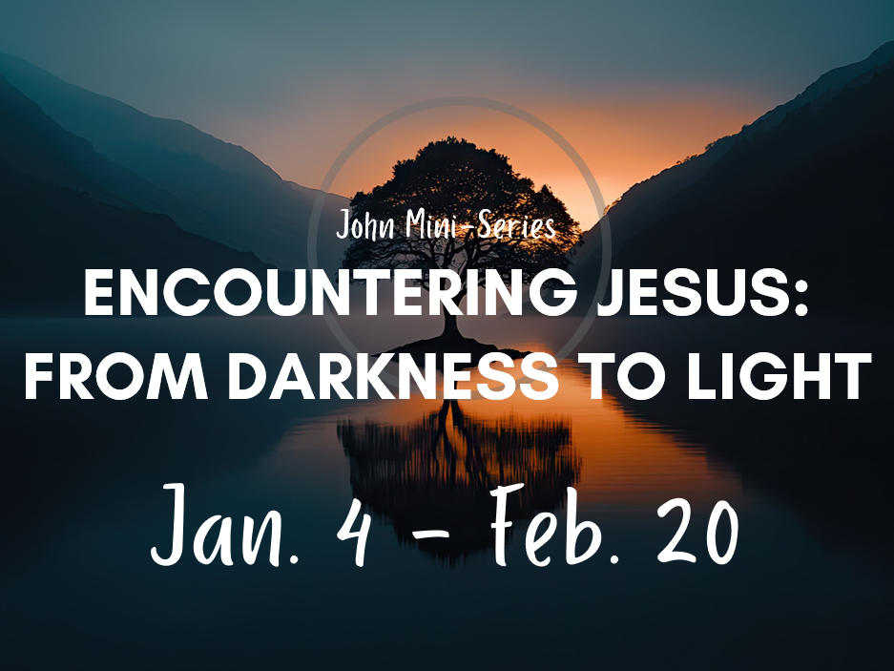

Morning Worship Service
Sunday, January 18, 2026
8:30 and 11:00 a.m.

“Love God, Grow Together, and Serve Others by Following Jesus”

Fairview Church
2508 Old Niles Ferry Road
Maryville, Tennessee 37803
865-983-2080
www.Fairview-Church.org

