Morning Worship
THE LORD’S DAY
Sunday, December 7, 2025
8:30 and 11:00 a.m.
The Second Sunday of Advent
“For all have sinned and fall short of the glory of God, and all are justified freely by his grace through the redemption that came by Christ Jesus.”
Romans 3: 23 & 24

Welcome Rev. Robert Castile

Prelude “Fum, Fum, Fum” Marguerite Wardlaw

Prayer Wesley Rouse

*Hymns of Praise
“Hark! The Herald Angels Sing”
Hark! the herald angels sing, “Glory to the newborn King:
Peace on earth, and mercy mild, God and sinners reconciled!”
Joyful, all ye nations, rise, Join the triumph of the skies;
With angelic hosts proclaim, “Christ is born in Bethlehem!”

Hark! The herald angels sing,
“Glory to the newborn King.”

Christ, by highest heaven adored; Christ, the everlasting Lord!
Late in time behold Him come, Offspring of a virgin's womb.
Veiled in flesh the Godhead see; Hail th'incarnate Deity,
Pleased as man with men to dwell, Jesus, our Emmanuel.

Hail the heav'n-born Prince of Peace! Hail the Sun of Righteousness!
Light and life to all He brings, Ris'n with healing in His wings.
Mild He lays His glory by, Born that man no more may die;
Born to raise us from the earth, Born to give us second birth.

“Angels We Have Heard on High”
Angels we have heard on high,
Sweetly singing o'er the plains;
And the mountains in reply,
Echoing their joyous strains.

Gloria, in excelsis Deo!
Gloria, in excelsis Deo!

Shepherds, why this jubilee?
Why your joyous strains prolong?
Say what may the tidings be;
Which inspire your heav'nly song?

Come to Bethlehem and see,
Him whose birth the angels sing;
Come adore on bended knee,
Christ the Lord, the newborn King.

See within a manger laid,
Jesus, Lord of heav'n and earth;
Mary, Joseph, lend your aid,
With us sing our Savior's birth.
Offertory Prayer Rev. Castile

Anthem Worship Choir & Orchestra
“Amen”
Max Hazelwood, solo
Amen, amen, amen!
Go tell it on the mountain,
Over the hills, and ev’rywhere.
Go, tell it on the mountain
That Jesus Christ is born.

See the little Baby (amen)
Lyin’ in a manger (amen)
On Christmas morning.
Amen, amen, amen.

While shepherds kept their watching
O’er silent flocks by night,
Behold, throughout the heavens
There shone a holy light.

See Him at the seashore (amen)
Talkin’ to the fishermen (amen)
And making them disciples.
Amen, amen, amen.

While shepherds feared and trembled
When lo, above the earth
Rang out the angel chorus
That hailed our Savior’s birth.

Down in the lowly manger
The humble Christ was born.
God sent to us salvation
That blessed Christmas morn.

See Him in the garden (amen)
Praying to His Father (amen)
In deepest sorrow.
Amen, amen, amen.

Glory Hallelujah! (amen)
He died to save us! (amen)
And He lives forever!
Amen, amen, amen!
He died to save you and me! (amen)

Children’s Sermon Rev. Gilbert Harris
Please be aware that if your child comes forward during this time, they will be visible on the livestream of the service.
Lighting of the Advent Candle: Peace

*Passing the Peace Rev. Harris
Pre-K worship begins at 8:15a.m. and those children may be taken by a parent to their class anytime. K – 1st graders go to Kid’s Church during the “Passing of the Peace.” If you have not signed them up for Kid’s Church, please escort your child to the Great Hall.

*Hymns of Faith
“Infant Holy, Infant Lowly”
Infant holy, Infant lowly,
For His bed a cattle stall;
Oxen lowing, little knowing
Christ, the Babe, is Lord of all.

Swift are winging angels singing,
Noels ringing, tidings bringing:
Christ, the Babe, is Lord of all!
Christ, the Babe, is Lord of all!

Flocks were sleeping, Shepherds keeping
Vigil till the morning new
Saw the glory, heard the story,
Tidings of a gospel true.
Thus rejoicing, free from sorrow,
Praises voicing greet the morrow:
Christ, the Babe, was born for you!
Christ, the Babe, was born for you!

“Come, Just As You Are”
Come just as you are;
hear the Spirit call.
Come just as you are;
come and see; come receive;
come and live forever.

Life everlasting, and strength for today;
taste the Living Water, and never thirst again.

Come just as you are;
hear the Spirit call.
Come just as you are;
come receive Christ, the King;
come and live forevermore.

Family Prayer Rev. Harris

THE LORD’S PRAYER
Our Father, Who art in heaven, hallowed be Thy name. Thy kingdom come, Thy will be done on earth as it is in heaven. Give us this day our daily bread; and forgive us our trespasses as we forgive those who trespass against us. And lead us not into temptation, but deliver us from evil, for Thine is the kingdom, and the power and the glory forever. Amen.

*Scripture Reading Luke 2:8-20

Message “Good News” Rev. Harris

Holy Communion The Great Thanksgiving
The Lord be with you.
And also with you.
Lift up your hearts.
We lift them up to the Lord.
Let us give thanks to the Lord our God.
It is right to give our thanks and praise.

It is right, and a good and joyful thing,
always and everywhere to give thanks to You,
Father God Almighty, Creator of heaven and earth.
Our souls magnify You oh Lord,
our spirits rejoice in You our Savior.
You have done great things for us,
and holy is Your name.

And so, with Your people on earth and all the company of heaven,
we praise Your name and join their unending hymn:

Holy, holy, holy Lord, God of power and might,
Heaven and earth are full of Your glory.
Hosanna in the highest.
Blessed is he who comes in the name of the Lord.
Hosanna in the highest.

Holy are You, and blessed is Your Son Jesus Christ.
Through Him, You have brought down the powerful from their thrones,
and lifted up the lowly.

Your Spirit anointed Him
to preach good news to the poor,
to proclaim release to the captives and
recovering of sight to the blind,
to set at liberty those who are oppressed, and
to announce that the time had come
when You would save Your people.
He healed the sick, fed the hungry, and ate with sinners.

By the baptism of His suffering, death, and resurrection
You gave birth to Your Church,
delivered us from slavery to sin and death,
and made with us a new covenant
by water and the Spirit.

On the night in which He gave himself up for us, He took bread,
gave thanks to You, broke the bread, gave it to His disciples, and said,
"Take, eat; this is My body which is given for you.
Do this in remembrance of Me."

When the supper was over He took the cup,
gave thanks to You, gave it to His disciples, and said:
"Drink from this, all of you; this is My blood of the new covenant,
poured out for you and for many for the forgiveness of sins.
Do this, as often as you drink it, in remembrance of Me."

And so, in remembrance of these Your mighty acts in Jesus Christ,
we offer ourselves in praise and thanksgiving
as a holy and living sacrifice, in union with Christ's offering for us,
as we proclaim the mystery of faith.

Christ has died; Christ is risen; Christ will come again.

Pour out Your Holy Spirit on us gathered here,
and on these gifts of bread and wine.
Make them be for us the body and blood of Christ,
that we may be for the world the body of Christ, redeemed by His blood,
that we might be patient for the coming of the Lord.

By Your Spirit make us one with Christ,
one with each other and
one in ministry to all the world,
until Christ comes in final victory and
we feast at the heavenly banquet.

Through your Son Jesus Christ, with the Holy Spirit in your holy Church,
all honor and glory is yours, almighty Father, now and forever. Amen.

All People who intend to lead a Christian life are invited to receive this holy sacrament. Please come forward as the ushers give directions. Prepackaged elements and gluten-free wafers are available on the Altar. After receiving Communion, you are welcome to kneel and pray at the altar.

“What a Beautiful Name”
You were the Word at the beginning;
one with God the Lord Most High.
Your hidden glory in creation,
now revealed in You, our Christ.

What a beautiful name it is. What a beautiful name it is;
the name of Jesus Christ, my King.
What a beautiful name it is. Nothing compares to this.
What a beautiful name it is; the name of Jesus.

You didn't want heaven without us,
so Jesus, You brought heaven down.
My sin was great. Your love was greater.
What could separate us now.

What a wonderful name it is. What a wonderful name it is;
the name of Jesus Christ, my King.
What a wonderful name it is. Nothing compares to this.
What a wonderful name it is; the name of Jesus.

Death could not hold You. The veil tore before You.
You silence the boast of sin and grave.
The heavens are roaring the praise of Your glory,
for You are raised to life again.

You have no rival! You have no equal!
Now and forever, God, You reign!
Yours is the kingdom! Yours is the glory!
Yours is the name above all names!

*Benediction Rev. Harris

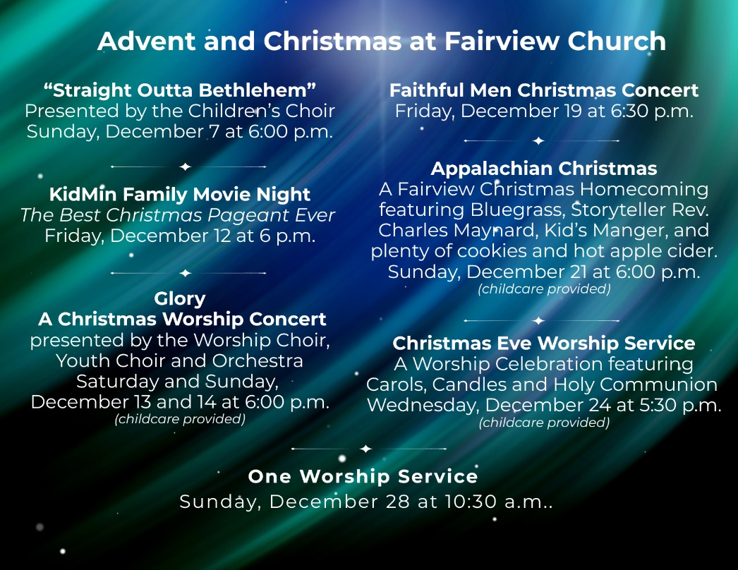
New Here?   | Prayers   | E-Giving   | Newsletter  



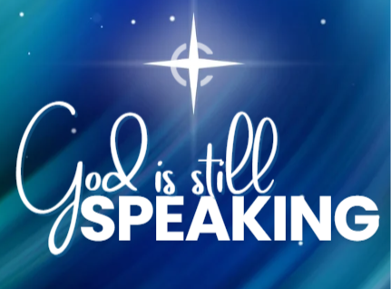

Morning Worship Service
Sunday, December 7, 2025
8:30 and 11:00 a.m.

“Love God, Grow Together, and Serve Others by Following Jesus”

Fairview Church
2508 Old Niles Ferry Road
Maryville, Tennessee 37803
865-983-2080
www.Fairview-Church.org

