Morning Worship
THE LORD’S DAY
Sunday, November 23, 2025
8:30 and 11:00 a.m.
Christ the King Sunday
Thanksgiving Sunday
“Oh come, let us sing to the LORD!
Let us shout joyfully to the Rock of our salvation.
Let us come before His presence with thanksgiving;
Let us shout joyfully to Him with psalms.” Psalm 95: 1 & 2

Welcome Rev. Robert Castile

Prelude “Old Hundredth” Marguerite Wardlaw

Prayer Wesley Rouse

*Hymns and Psalm of Praise
“All People that On Earth Do Dwell”
All people that on earth do dwell,
Sing to the Lord with cheerful voice.
Him serve with fear; His praise forth tell.
Come ye before Him and rejoice.

The Lord, ye know, is God indeed;
Without our aid He did us make.
We are His flock; He doth us feed.
And for His sheep He doth us take.

O enter then His gates with praise;
Approach with joy His courts unto.
Praise, laud, and bless His name always,
For it is seemly so to do.

For why? The Lord our God is good;
His mercy is forever sure.
His truth at all times firmly stood,
And shall from age to age endure.

Praise God, from whom all blessings flow;
Praise Him, all creatures here below;
Praise Him above, ye heavenly host.
Praise Father, Son and Holy Ghost.
Amen.

Psalm 100
(From the Geneva Bible 1599)
Sing ye loud unto the Lord, all the earth.
Serve the Lord with gladness:
come before Him with joyfulness.

Know ye that even the Lord is God:
He hath made us, and not we ourselves:
We are His people, and the sheep of His pasture.

Enter into His gates with praise,
and into His courts with rejoicing:
Praise Him and bless His Name.

For the Lord is good:
His mercy is everlasting,
and His truth is from generation to generation.
“You Are Good”
Lord, You are good
And Your mercy endureth forever.
Lord, You are good
And Your mercy endureth forever.
People from every nation and tongue,
From generation to generation,

We worship You.
Hallelujah! Hallelujah!
We worship You for who You are.

We worship You.
Hallelujah! Hallelujah!
We worship You for who You are
and You are good.

Offertory Prayer Rev. Castile

Anthem Worship Choir & Orchestra
“That’s My King”
Kunita Gear, Solo
I wish I could tell you, wish I could describe it;
But I can’t contain it, can’t keep it to myself.
There aren’t enough colors to paint the whole picture;
Not enough words to ever say what I found.

Wonderful and beautiful
And glorious and holy.
He is merciful and powerful!
Who we talking about? That’s my King!

We declare the glory! Give Him all the honor!
Altogether worthy! Who we talking about?
That’s my King!
There’s no one before You! Yes, we will adore You!
All of this is for You! Who we talking about?
That’s my King!

I’m not letting the rocks cry without joining the chorus.
There aren’t enough notes to make the harmony.
It’s the song of the angels through all of the ages.
It’s all of the earth and heaven’s symphony!

That’s my King! That’s my God!
That’s my Shepherd, My Protector!
That’s my King! That’s my Rock!
That’s my Anchor, My Defender!

Who we talking about?
That’s my King!

Children’s Sermon Rev. Gilbert Harris
Please be aware that if your child comes forward during this time, they will be visible on the livestream of the service.

*Passing the Peace Rev. Harris
Pre-K worship begins at 8:15a.m. and those children may be taken by a parent to their class anytime. K – 5th graders go to Kid’s Church during the “Passing of the Peace.” If you have not signed them up for Kid’s Church, please escort your child to the Great Hall.

*Hymns of Faith
“We Gather Together”
We gather together to ask the Lord's blessing;
He chastens and hastens His will to make known;
The wicked oppressing now cease from distressing,
Sing praises to His name: He forgets not His own.

Beside us to guide us, our God with us joining,
Ordaining, maintain, His kingdom divine;
So from the beginning the fight we were winning;
Thou, lord, was at our side all glory be Thine!

We all do extol Thee, Thou leader triumphant,
And pray that Thou still our defender wilt be.
Let Thy congregation escape tribulation:
Thy name be ever praised! O Lord, make us free!

“Goodness of God”
I love You, Lord. Oh Your mercy never fails me;
all my days I've been held in Your hands.
From the moment that I wake up until I lay my head.
I will sing of the goodness of God.

And all my life You have been faithful.
And all my life You have been so, so good.
With every breath that I am able
Oh, I will sing of the goodness of God.

I love Your voice; You have led me through the fire.
And in darkest nights, You are close like no other.
I've known You as a father, I've known You as a friend.
And I have lived in the goodness of God.

‘Cause Your goodness is running after, it’s running after me.
Your goodness is running after it’s running after me.
With my life laid down, I’m surrendered now.
I give You everything.
‘Cause Your goodness is running after,
it's running after me.
Family Prayer Rev. Harris

THE LORD’S PRAYER
Our Father, Who art in heaven, hallowed be Thy name. Thy kingdom come, Thy will be done on earth as it is in heaven. Give us this day our daily bread; and forgive us our trespasses as we forgive those who trespass against us. And lead us not into temptation, but deliver us from evil, for Thine is the kingdom, and the power and the glory forever. Amen.

*Scripture Reading Psalm 100

Message “Thanksgiving Truths” Rev. Harris

*Hymn of Invitation
“Give Thanks”
Give thanks with a grateful heart,
Give thanks to the Holy One,
Give thanks because He’s given
Jesus Christ His Son.

And now let the weak say, “I am strong!”
Let the Poor say, “I am rich,
Because of what the Lord has done for us!”
*Benediction Rev. Harris

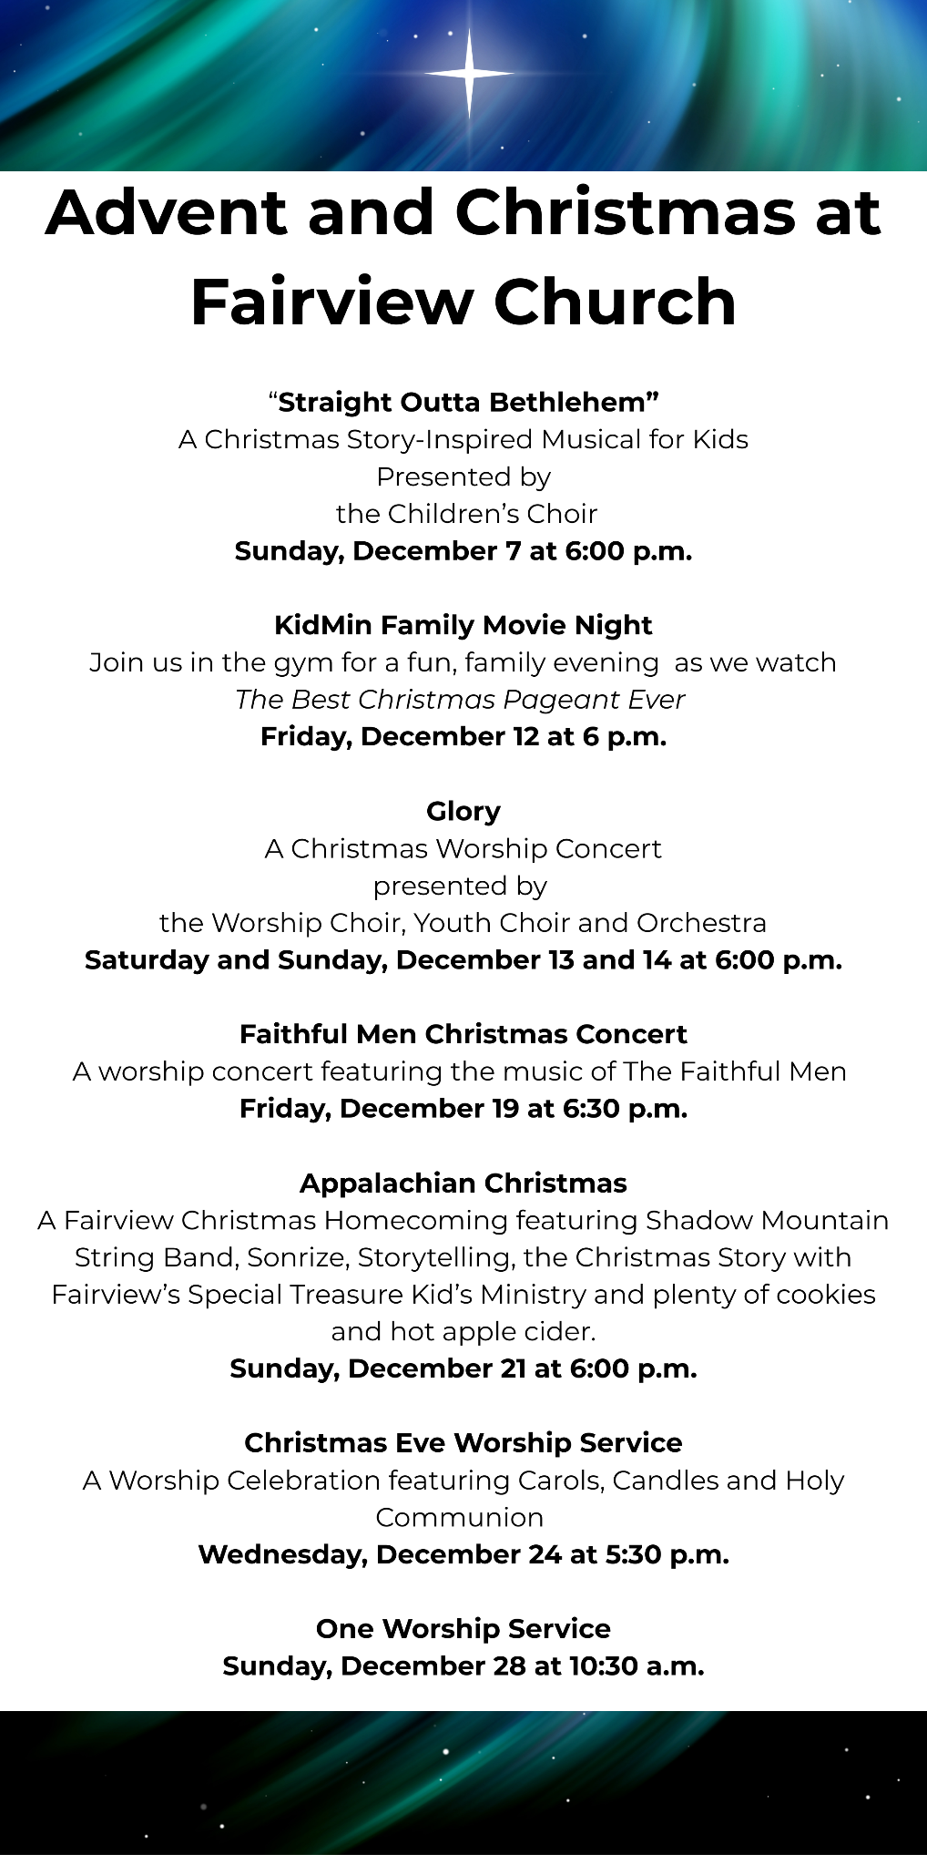
Prayer Requests
CHURCH STAFF:
Rev. Gilbert Harris, Senior Pastor
Rev. Robert Castile, Associate Pastor
Melissa Tyler, Executive Director
Wesley Rouse, Minister of Music
Robby Clemens, Administrative Assistant, Music Ministry
Marguerite Wardlaw, Organist, Music Ministry
Sandra Rouse, Pianist, Music Ministry
Mindy Richardson, Children’s Choir Coordinator, Music Ministry
Joshua Bauer, Audio/Visual Coordinator
Mallory Davis, Connectional Ministry Director
Sherrie Miller, Administrative Assistant, (Pastor)
Donna Henry, Children’s Ministry Director
Sophie Goss, Children’s Ministry Coordinator
Roger Murphy, College Ministry Coordinator
Donna Foster, Social Media Specialist/Receptionist
Jennifer Cowan, Bookkeeper
Christy Wheeler, Director, Preschool Ministry
Tom Palmer, Facilities Manager
Kenny Francis, Facilities Maintenance

Missionaries: Costa Rica – Paul and Amy Priest; Guatemala/Orphanage, Hogar del Nino; Surge - Bruce & Kathy Alwood; Latvia – Kristine Rozefelde; Paraguay – New Horizons Schools; Zimbabwe – Eben and Nancy Chinzvende; Haiti – Gabe Lindor (Simple Church); Haiti – Daniel and Natalie Abercrombie (Access Health Alliance)
US Based: Pennsylvania - Shane Claiborne; Tennessee: Raising a Voice, John 3:16, Isaiah House, Smoky Mountain Fellowship of Christian Athletes

Ongoing Health Requests: Kenny Allmon, Vicki Borden, Marge Fugate, Judy Granlund, Kermit Marcus, Wanda Marion, Raina Karras Myers, Virginia Porter, Michael (Mike) Smith, Rick Toombs, John Wilson.

Current Health Requests: Allen and Jo Beliles, Levi Briskie, Katie Langham, Linda Kidd, Sierra McConnaugley, Bill Merry, Billy Minser, Jessica Moore, Curtis Trent.

Military: Air Force – Charlene Carpenter, Will Gratz, Jeff Heath*, Chad Humphrey, Josh Humphrey, Jef Hyatt, Blaine Nicholson, Jacob Robbins, Danny Smith, Rob Toth, Robb Wilson*, Brian Wright, Jared Cassady. Army – Neal Buckingham, Christopher Cogburn, Luke Cox*, Tony Ellis, Casey Gillis (training), Brad Hutsell, Jason McGeorge, Obed McPherson*, Stewart Milne, Eli Tate, Wes Tate. Marines – Mikeala Buckingham, Tyler Buckingham, Elijah Dean*, Derek Reimann, Daniel Romans*. Navy – Jason Cassisi, Kurt Heidemann, Chandler Lekes*, Conner Lewis*, Austin Lyttle, Jonathan O'Bannon, Mark Robinson*, Alex Simmons, Jonah Watson*. Air National Guard –Tyler Isaacs*, Scott Pritchard, Zach Tate.
(*= Deployed)

New Here?   | Prayers   | E-Giving   | Newsletter  





Morning Worship Service
Sunday, November 23, 2025
8:30 and 11:00 a.m.

“Love God, Grow Together, and Serve Others by Following Jesus”

Fairview Church
2508 Old Niles Ferry Road
Maryville, Tennessee 37803
865-983-2080
www.Fairview-Church.org

