Morning Worship
THE LORD’S DAY
Sunday, October 12, 2025
8:30 and 11:00 a.m.
The Eighteenth Sunday after Pentecost
“The Son is the image of the invisible God,
the firstborn over all creation.”
Colossians 1:15

Welcome Rev. Robert Castile

Prelude “How Firm a Foundation” Glory Ringers

Prayer Wesley Rouse

*Hymns of Praise
“When Morning Gilds the Skies”
When morning gilds the skies, my heart awaking cries;
May Jesus Christ be praised!
Alike at work and prayer, to Jesus I repair;
May Jesus Christ be praised!

The night becomes as day when from the heart we say,
May Jesus Christ be praised!
The powers of darkness fear, when this sweet song they hear:
May Jesus Christ be praised!

Ye nations of mankind, in this your concord find:
May Jesus Christ be praised!
Let all the earth around ring joyous with the sound:
May Jesus Christ be praised!

Be this, while life is mine, my canticle divine:
May Jesus Christ be praised!
Be this th’eternal song through all the ages long:
May Jesus Christ be praised!

“Hymn of Heaven”
How I long to breathe the air of Heaven,
Where pain is gone and mercy fills the streets,
To look upon the one who bled to save me
And walk with Him for all eternity.

There will be a day when all will bow before Him,
There will be a day when death will be no more,
Standing face to face with He who died and rose again.
Holy, holy is the Lord.

And ev'ry prayer we prayed in desperation,
The songs of faith we sang through doubt and fear;
In the end we’ll see that it was worth it,
When He returns to wipe away our tears.

And on that day, we join the resurrection
And stand beside the heroes of the faith.
With one voice a thousand generations
Sing, “Worthy is the Lamb who was slain.”
And on that day, we join the resurrection
And stand beside the heroes of the faith.
With one voice a thousand generations
Sing, “Worthy is the Lamb who was slain.”
Forever He shall reign!

So let it be today we shout the hymn of Heaven.
With angels and the Saints we raise a mighty roar!
Glory to our God who gave us life beyond the grave.
Holy, holy is the Lord.
Holy, holy, holy! All the saints adore Thee,
Casting down their golden crowns around the glassy sea.
Cherubim and seraphim, falling down before Thee,
Which wert, and art, and evermore shall be!

Offertory Prayer Rev. Castile

Anthem Worship Choir & Orchestra
“Bless God”
Mindy Richardson, solo
Blessed are those who run to Him,
who place their hope and confidence in Jesus;
He won’t forsake them;
Blessed are those who seek His face,
Who bend their knee and fix their gaze on Jesus;
They won’t be shaken.

Come on and praise the Lord with me,
Sing if you love His name;
Come on and lift your voice with me,
He’s worthy of all our praise.

Blessed are those who walk with Him,
Whose hearts are set on pilgrimage with Jesus;
They’ll see His glory.
Blessed are those who die to live, whose joy it is to give it all for Jesus
And for Him only;
O Jesus, all for Your glory.

Bless God in the sanctuary,
Bless God in the fields of plenty,
Bless God in the darkest valley,
Every change I get, I’ll bless Your name.

Bless God when my hands are empty;
Bless God with a praise that costs me;
Bless God when nobody’s watching.
Every change I get, I’ll bless Your name.

Bless God when the weapon’s forming,
Bless God when the walls are falling,
Bless God ‘cause He goes before me,
Every change I get, I bless Your name.

Bless God for He holds the victory,
Bless God for He’s always with me;
Bless God for He’s always worthy,
Every change I get, I bless Your name.

Children’s Sermon Rev. Gilbert Harris
Please be aware that if your child comes forward during this time, they will be visible on the livestream of the service.

*Passing the Peace Rev. Harris
Pre-K worship begins at 8:15a.m. and those children may be taken by a parent to their class anytime. K – 5th graders go to Kid’s Church during the “Passing of the Peace.” If you have not signed them up for Kid’s Church, please escort your child to the Great Hall.

*Affirmation of Faith
1 Corinthians 15:1-16 and Colossians 1:15-20
This is the good news

which we have received,

In which we stand,

and by which we are saved:

Christ died for our sins, was buried,

was raised on the third day,

and appeared first to the women,

then to Peter and the Twelve,

and then to many faithful witnesses.

We believe Jesus is the Christ,

the Anointed One of God,

the firstborn of all creation,

the firstborn from the dead,

in whom all things hold together,

in whom the fullness of God

was pleased to dwell

by the power of the Spirit.

Christ is the head of the body, the

church, and by the blood of the cross

reconciles all things to God. Amen.

*Hymns of Faith
“O How I Love Jesus”
There is a name I love to hear,
I love to sing its worth;
It sounds like music in my ear,
The sweetest name on earth.

O, how I love Jesus!
O, how I love Jesus!
O, how I love Jesus,
Because He first loved me!

It tells me of a Savior's love,
Who died to set me free;
It tells me of His precious blood,
The sinner's perfect plea.

It tells of One whose loving heart
Can feel my deepest woe,
Who in each sorrow bears a part
That none can bear below.

“Good, Good Father”
I've heard a thousand stories of what they think You’re like,
but I've heard the tender whisper of love in the dead of night.
And You tell me that You’re pleased and that I'm never alone.

You're a Good, Good Father.
It's who You are, it's who You are, it's who You are.
And I'm loved by You; It's who I am,
it's who I am, it's who I am.

Oh, and I've seen many searching for answers far and wide,
but I know we're all searching for answers only You provide.
‘Cause You know just what we need before we say a word.

You are perfect in all of Your ways.
You are perfect in all of Your ways.
You are perfect in all of Your ways to us.

Oh, it’s love so undeniable, I, I can hardly speak.
Peace so unexplainable, I, I can hardly think;
as You call me deeper still, as You call me deeper still,
as You call me deeper still into love, love, love.

Family Prayer Time

THE LORD’S PRAYER
Our Father, Who art in heaven, hallowed be Thy name. Thy kingdom come, Thy will be done on earth as it is in heaven. Give us this day our daily bread; and forgive us our trespasses as we forgive those who trespass against us. And lead us not into temptation, but deliver us from evil, for Thine is the kingdom, and the power and the glory forever. Amen.

*Scripture Reading John 5:16-44

Message “The Defense of Jesus” Rev. Harris

*Hymn of Invitation
“I Offer My Life”
Lord, I offer my life to You;
everything I’ve been through,
Use it for Your glory.

Lord, I offer my days to You,
Lifting my praise to You
As a pleasing sacrifice;
Lord, I offer You my life.

Benediction Rev. Harris

Congratulations to Gabe and Katie Bailey on the birth of their son, James Leon Allan Bailey.

Christian sympathy is extended to Kathy Holowinsky and family on the death of her sister, Sandra Gleason, and to Jessica Lewis and family on the death of her grandfather, George Lewis.

Prayer Requests
CHURCH STAFF:
Rev. Gilbert Harris, Senior Pastor
Rev. Robert Castile, Associate Pastor
Melissa Tyler, Executive Director
Wesley Rouse, Minister of Music
Robby Clemens, Administrative Assistant, Music Ministry
Marguerite Wardlaw, Organist, Music Ministry
Sandra Rouse, Pianist, Music Ministry
Mindy Richardson, Children’s Choir Coordinator, Music Ministry
Joshua Bauer, Audio/Visual Coordinator
Mallory Davis, Connectional Ministry Director
Sherrie Miller, Administrative Assistant, (Pastor)
Donna Henry, Children’s Ministry Director
Sophie Goss, Children’s Ministry Coordinator
Jamie Talley, Youth Minister
Roger Murphy, College Ministry Coordinator
Donna Foster, Social Media Specialist/Receptionist
Jennifer Cowan, Bookkeeper
Christy Wheeler, Director, Preschool Ministry
Tom Palmer, Facilities Manager
Kenny Francis, Facilities Maintenance

Missionaries: Costa Rica – Paul and Amy Priest; Guatemala/Orphanage, Hogar del Nino; Surge - Bruce & Kathy Alwood; Latvia – Kristine Rozefelde; Paraguay – New Horizons Schools; Zimbabwe – Eben and Nancy Chinzvende; Haiti – Gabe Lindor (Simple Church); Haiti – Daniel and Natalie Abercrombie (Access Health Alliance)
US Based: Pennsylvania - Shane Claiborne; Tennessee: Raising a Voice, John 3:16, Isaiah House, Smoky Mountain Fellowship of Christian Athletes

Ongoing Health Requests: Kenny Allmon, Vicki Borden, Marge Fugate, Judy Granlund, Kermit Marcus, Wanda Marion, Raina Karras Myers, Virginia Porter, Michael (Mike) Smith, Rick Toombs, John Wilson.

Current Health Requests: Allen and Jo Beliles, Levi Briskie, Katie Langham, Linda Kidd, Sierra McConnaugley, Bill Merry, Billy Minser, Jessica Moore, Velma Spradlin, Curtis Trent, Janie Watson.

Military: Air Force – Charlene Carpenter, Will Gratz, Jeff Heath*, Chad Humphrey, Josh Humphrey, Jef Hyatt, Blaine Nicholson, Jacob Robbins, Danny Smith, Rob Toth, Robb Wilson*, Brian Wright, Jared Cassady. Army – Neal Buckingham, Christopher Cogburn, Luke Cox*, Tony Ellis, Casey Gillis (training), Brad Hutsell, Jason McGeorge, Obed McPherson*, Stewart Milne, Eli Tate, Wes Tate. Marines – Mikeala Buckingham, Tyler Buckingham, Elijah Dean*, Derek Reimann, Daniel Romans*. Navy – Jason Cassisi, Kurt Heidemann*, Chandler Lekes*, Conner Lewis*, Austin Lyttle, Jonathan O'Bannon, Mark Robinson*, Alex Simmons, Jonah Watson*. Air National Guard –Tyler Isaacs*, Scott Pritchard, Zach Tate.
(*= Deployed)

Welcome    Visitors | Prayers  & Praises   |   Give | Spiritual Gifts Survey  



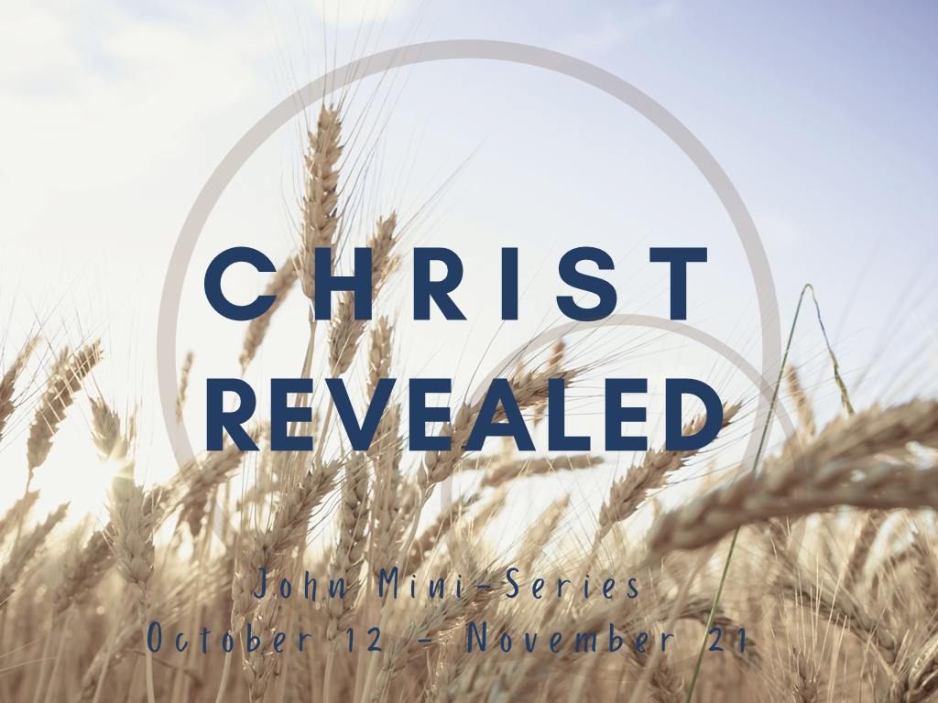

Morning Worship Service
Sunday, October 12, 2025
8:30 and 11:00 a.m.

“Love God, Grow Together, and Serve Others by Following Jesus”

Fairview Church
2508 Old Niles Ferry Road
Maryville, Tennessee 37803
865-983-2080
www.Fairview-Church.org

