Morning Worship
THE LORD’S DAY
Sunday, March 8, 2026
8:30 and 11:00 a.m.
The Third Sunday in Lent

“I am the vine; you are the branches. If you remain in me and I in you, you will bear much fruit; apart from me you can do nothing.” John 15:5

Welcome Rev. Robert Castile

Prelude David Cline

Prayer Wesley Rouse

*Hymns of Praise
“Praise Him! Praise Him!”
Praise Him! Praise Him!
Jesus our blessed Redeemer!
Sing, O earth, His wonderful love proclaim!
Hail Him! Hail Him! Highest archangels in glory,
Strength and honor give to His holy name!
Like a shepherd Jesus will guard His children,
In His arms He carries them All day long.

Praise Him! Praise Him!
Tell of His excellent greatness,
Praise Him! Praise Him!
Ever in joyful song.

Praise Him! Praise Him!
Jesus our blessed Redeemer!
For our sins He suffered and bled, and died.
He, our Rock, our hope of eternal salvation,
Hail Him! Hail Him! Jesus, the Crucified.
Sound His praises! Jesus who bore our sorrows,
Love unbounded, wonderful, deep and strong!

Praise Him! Praise Him!
Jesus our blessed Redeemer.
Heavenly portals, loud with hosannas ring!
Jesus, Savior, Reigneth forever and ever,
Crown Him! Crown Him! Prophet, and Priest, and King!
Christ is coming, over the world victorious;
Power and glory Unto the Lord belong!

Psalm 145:1-7
I will exalt you, my God the King;
I will praise your name for ever and ever.
Every day I will praise you
and extol your name for ever and ever.
Great is the LORD and most worthy of praise;
His greatness no one can fathom.
One generation commends your works to another;
They tell of your mighty acts.
They speak of the glorious splendor of your majesty —
And I will meditate on your wonderful works.
They tell of the power of your awesome works —
And I will proclaim your great deeds.
They celebrate your abundant goodness
And joyfully sing of your righteousness.
“Friend of God”
Who am I that You are mindful of me,
That You hear me when I call?
Is it true that You are thinking of me?
How You love me, it's amazing!

I am a friend of God! I am a friend of God!
I am a friend of God! He calls me friend!

God Almighty, Lord of glory,
You have called me friend!
Offertory Prayer Rev. Castile

Anthem Worship Choir & Orchestra

“Love of God”
He has done marvelous,
He has done marvelous things,
Praise the Lord!
Marvelous, marvelous,
Marvelous, marvelous things,
Praise the Lord!
He’s done marvelous,
He’s done marvelous things,
Praise the Lord!

Thine shall the glory be forever and evermore.
Thine shall the glory be throughout eternity.
I want to thank You Lord, for saving my soul.
Thank You, Lord, for making me whole.
Thine shall the glory be forever more.

He has done wonderful, He has done wonderful things,
Praise the Lord!

Marvelous! Wonderful! Hallelujah!
He’s been good!
Praise Him!
Brought me out, brought me through!
Thine shall the glory be forever more.

Children’s Sermon Rev. Gilbert Harris
Please be aware that if your child comes forward during this time, they will be visible on the livestream of the service.

*Passing the Peace Rev. Harris
Pre-K worship begins at 8:15a.m. and those children may be taken by a parent to their class anytime. K – 5th graders go to Kid’s Church during the “Passing of the Peace.” If you have not signed them up for Kid’s Church, please escort your child to the Great Hall.

*Hymns of Faith
“No, Not One”
There's not a friend like the lowly Jesus,
No, not one! No, not one!
None else could heal all our soul's diseases,
No, not one! No, not one!

Jesus knows all about our struggles;
He will guide till the day is done.
There's not a friend like the lowly Jesus,
No, not one! No, not one!

There's not an hour that He is not near us,
No, not one! No, not one!
No night so dark but His love can cheer us,
No, not one! No, not one!

Was there a gift like the Savior given?
No, not one! No, not one!
Will He refuse us a home in heaven?
No, not one! No, not one!

Prayer Requests
You are invited to come forward and pray at the altar during the Family Prayer
time. If you would like to be anointed with oil and prayed for during this time, please meet Pastor Castile at the altar.

Call to Prayer “Holy God” Trisagion (Thrice Holy)
Holy God, Holy and Mighty,
Holy Immortal One,
have mercy; have mercy on us.

Family Prayer Rev. Harris

THE LORD’S PRAYER
Our Father, Who art in heaven, hallowed be Thy name. Thy kingdom come, Thy will be done on earth as it is in heaven. Give us this day our daily bread; and forgive us our trespasses as we forgive those who trespass against us. And lead us not into temptation, but deliver us from evil, for Thine is the kingdom, and the power and the glory forever. Amen.

*Scripture Reading John 15:1-17

Message “The Branches and the Vine” Rev. Harris

*Hymn of Invitation
“I Surrender All”
All to Jesus I surrender,
All to Him I freely give;
I will ever love and trust Him,
In His presence daily live.

I surrender all, I surrender all;
All to Thee my blessed Savior,
I surrender all.

All to Jesus I surrender,
Make me, Savior, wholly Thine;
Let me feel Thy Holy Spirit,
Truly know that Thou art mine.

All to Jesus I surrender,
Lord, I give myself to Thee.
Fill me with Thy love and power,
Let Thy blessing fall on me.

*Benediction Rev. Harris

Christian sympathy is extended to the family of Lloyd Weston Smith.
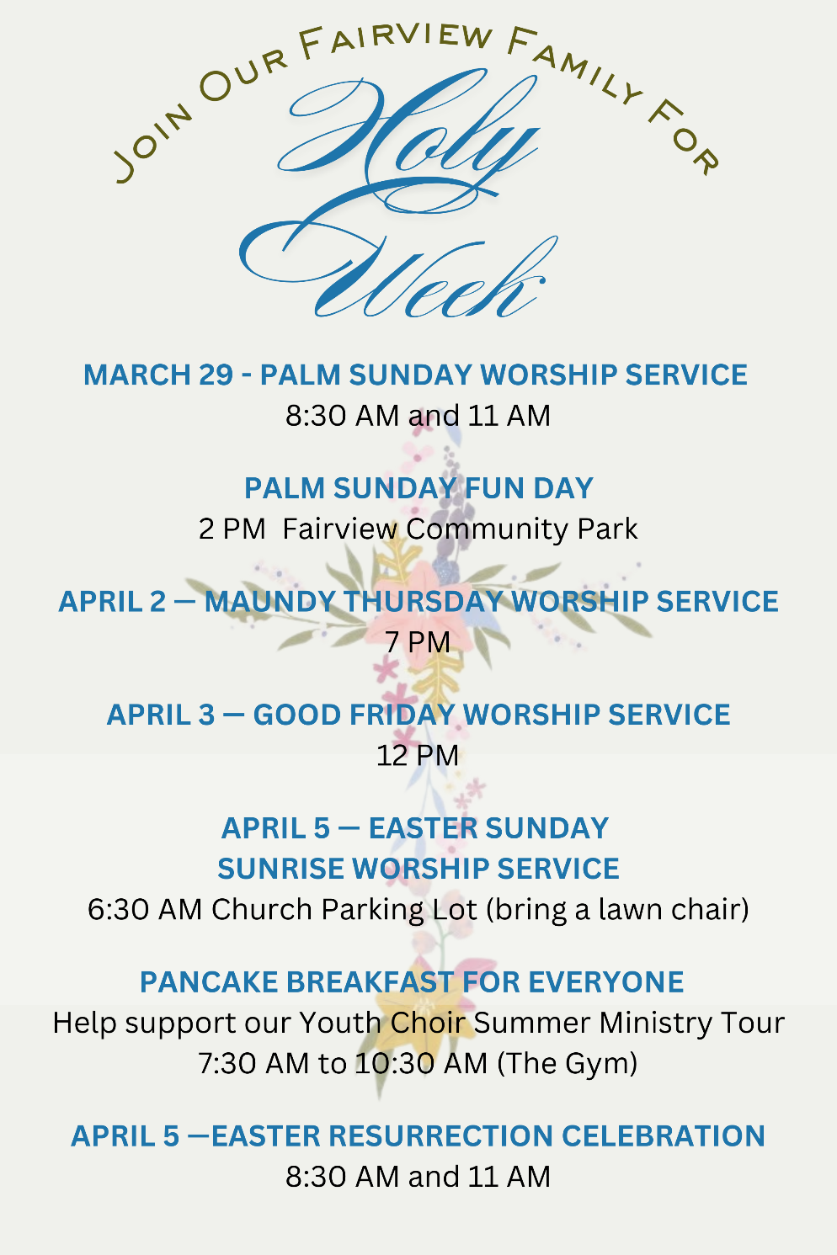

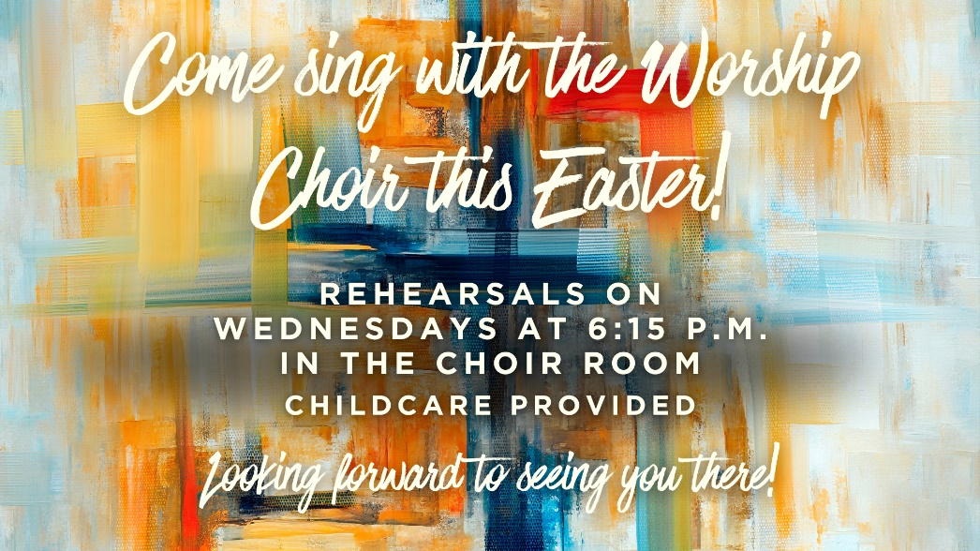
Prayer Requests
CHURCH STAFF:
Rev. Gilbert Harris, Senior Pastor
Rev. Robert Castile, Associate Pastor
Melissa Tyler, Executive Director
Wesley Rouse, Minister of Music
Robby Clemens, Administrative Assistant, Music Ministry
Marguerite Wardlaw, Organist, Music Ministry
Sandra Rouse, Pianist, Music Ministry
Mindy Richardson, Children’s Choir Coordinator, Music Ministry
Joshua Bauer, Audio/Visual Coordinator
Mallory Davis, Connectional Ministry Director
Sherrie Miller, Administrative Assistant, (Pastor)
Donna Henry, Children’s Ministry Director
Sophie Goss, Children’s Ministry Coordinator
Roger Murphy, College Ministry Coordinator
Donna Foster, Social Media Specialist/Receptionist
Jennifer Cowan, Bookkeeper
Christy Wheeler, Director, Preschool Ministry
Tom Palmer, Facilities Manager
Kenny Francis, Facilities Maintenance

Missionaries: Costa Rica – Paul and Amy Priest; Guatemala/Orphanage, Hogar del Nino; Surge - Bruce & Kathy Alwood; Latvia – Kristine Rozefelde; Paraguay – New Horizons Schools; Zimbabwe – Eben and Nancy Chinzvende; Haiti – Gabe Lindor (Simple Church); Haiti – Daniel and Natalie Abercrombie (Access Health Alliance)
US Based: Pennsylvania - Shane Claiborne; Tennessee: Raising a Voice, John 3:16, Isaiah House, Smoky Mountain Fellowship of Christian Athletes

Ongoing Health Requests: Kenny Allmon, Vicki Borden, Marge Fugate, Judy Granlund, Kermit Marcus, Wanda Marion, Raina Karras Myers, Virginia Porter, Michael (Mike) Smith, Rick Toombs, John Wilson.

Current Health Requests: Allen and Jo Beliles, Levi Briskie, Katie Langham, Linda Kidd, Sierra McConnaugley, Bill Merry, Billy Minser, Jessica Moore, George Pickard, Curtis Trent.

New Here?   | Prayers   | E-Giving   | Newsletter  
Military: Air Force – Charlene Carpenter, Will Gratz, Jeff Heath*, Chad Humphrey, Josh Humphrey, Jef Hyatt, Blaine Nicholson, Jacob Robbins, Danny Smith, Rob Toth, Robb Wilson*, Brian Wright, Jared Cassady. Army – Neal Buckingham, Christopher Cogburn, Luke Cox*, Tony Ellis, Casey Gillis (training), Brad Hutsell, Jason McGeorge, Obed McPherson*, Stewart Milne, Eli Tate, Wes Tate. Marines – Mikeala Buckingham, Tyler Buckingham, Elijah Dean*, Derek Reimann*, Daniel Romans*. Navy – Jason Cassisi, Kurt Heidemann, Chandler Lekes*, Conner Lewis*, Austin Lyttle, Jonathan O'Bannon, Mark Robinson*, Alex Simmons, Jonah Watson*, Jesse Williamson*. Air National Guard –Tyler Isaacs*, Scott Pritchard, Zach Tate.
(*= Deployed)



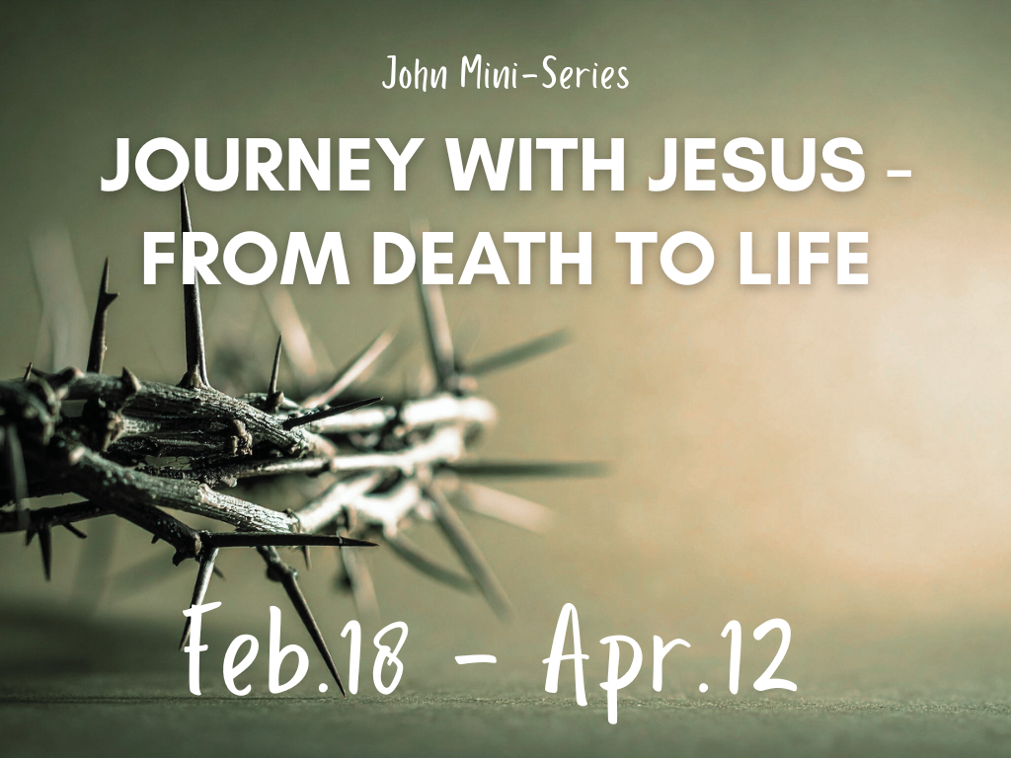

Morning Worship Service
Sunday, March 8, 2026
8:30 and 11:00 a.m.

“Love God, Grow Together, and Serve Others by Following Jesus”

Fairview Church
2508 Old Niles Ferry Road
Maryville, Tennessee 37803
865-983-2080
www.Fairview-Church.org

